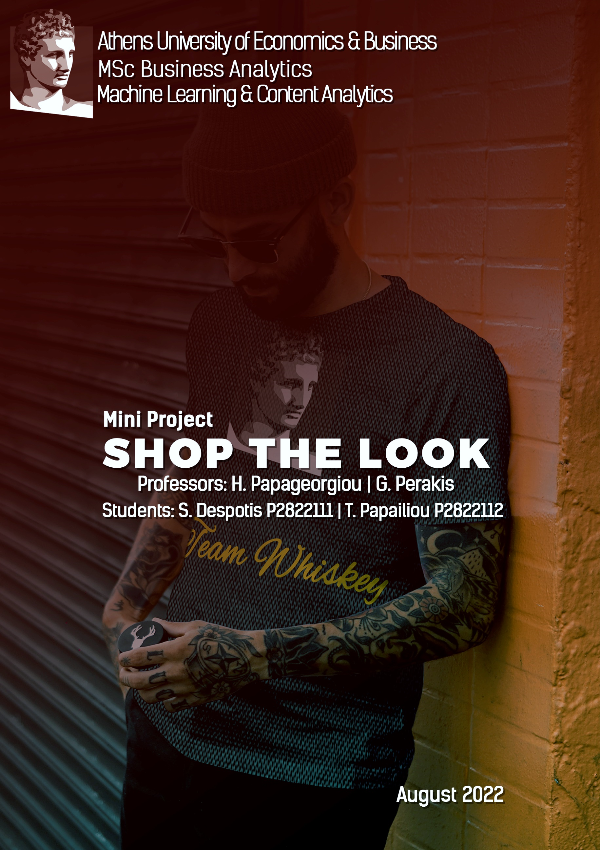

Contents

1. Introduction 2

1.1 Our Project Idea 2

1.2 Our Vision & Goals 3

2. Methodology 3

2.1 Proposed Solution 3

2.2 Data Collection 4

2.3 Exploratory Data Analysis 5

2.4 Gender Classification 7

2.5 Object Detection and Localization 9

2.6 Embedding Generation 15

3. Experiments – Setup, Configuration 27

3.1 Final Pipeline 27

3.2 Results & Quantitative Analysis 28

3.3 Further improvements and future work 34

4 Members, Roles & Timeplan 35

5 Bibliography 36

# Introduction

## Our Project Idea

Nowadays, many users in terms of fashion, are inspired from influencers (e.g. bloggers, tik-tokers etc.) or from people who saw in streets from their friends. Therefore, having the opportunity to take a picture or use an already taken picture with the desire outfit and find instantly similar outfits available to buy will give customers a great user experience. Also, visual search eliminates the drawbacks of text-based search.

Visual search poses some interesting challenges: how to deal with variations in image quality, lighting, background, different human poses, and article distortion, or finding the right product in a large database in real-time.

## Our Vision & Goals

Have you ever looked at a model and wondered if you could ever look like him/her? Ever wondered how to develop a good fashion sense? Our vision is to propose a solution to both of those questions. The rise of e-commerce websites in Greece has led to an increase in online shopping throughout the country. Fashion items are the most sought after in the e-commerce market. A robust, effective, and efficient recommendation system for fashion items could lead to an increase in revenue, better customer engagement, and experience. What makes this approach novel is the ability to detect multiple products from a given Product Display page and recommend similar items to the user. A Product Display Page (PDP) is a webpage that presents an image of the product/products worn by a model or a standalone picture of the product in a plain background. This approach helps the user to not only look for the relevant item in a single category but also to match those items with other items that go well with the specified product. In simple words, thanks to the advancements in computer vision, you can copy the look of your favourite celebrity by just using an image of that look.

# Methodology

## Proposed Solution

The proposed solution is a Content-Based recommendation system that involves various modules that carry specific tasks that help in achieving the overall goal. For the system proposed in the published article by [Myntra](https://arxiv.org/pdf/2008.11638.pdf) the first module consists of the Human Key Point Detection, looks for specific human key points like the ankle and the eyes in order to classify the image as a full-shot image i.e. an image that consists of the full body of a model, however the solution proposed skips this step, instead we'll recommend items using all the fashion products detected in an image.

For better product recommendation we'll first try to determine the gender of the person in the query image. The pose can either be front, back, left, right or detailed. After determining the gender, the input is fed is then fed to the next module, it’s an Object Detection module trained to identify objects from these broad categories - top-wear, bottom-wear, and footwear. The goal of this module is not just the identification of these objects in the image but also to localize the objects with bounding boxes. Once the bounding boxes are obtained for a certain object, that part of the image is cropped and the embeddings for the cropped image are obtained, which will help in identifying similar products from the catalogue/database of products whose semantic embeddings are already known.

We'll train a Siamese Network for generating the embeddings for the catalogue of images. This system helps in automatically and efficiently recommending new items to a user who has selected or shown interest in a certain product display page.

## Data Collection

To get started with the Fashion Recommendation Engine, we'll need a catalogue/database consisting of fashion products to recommend. Fortunately, Spyros and Thanasis are both working at Skroutz, so we have a database of these items lying around.

Since we'll focus on recommending items across various categories, we'll need a diverse set of fashion products to populate the database. We have used Skroutz’s database to query images using specific item categories and later save the product details for the results obtained. This way we can categorize products into various sections which would make it easier while recommending items.

## Exploratory Data Analysis

Now that we've gathered the catalogue, let’s do some exploratory analysis on it. The dataset consists of 9600 fashion products in various categories. The categories being:

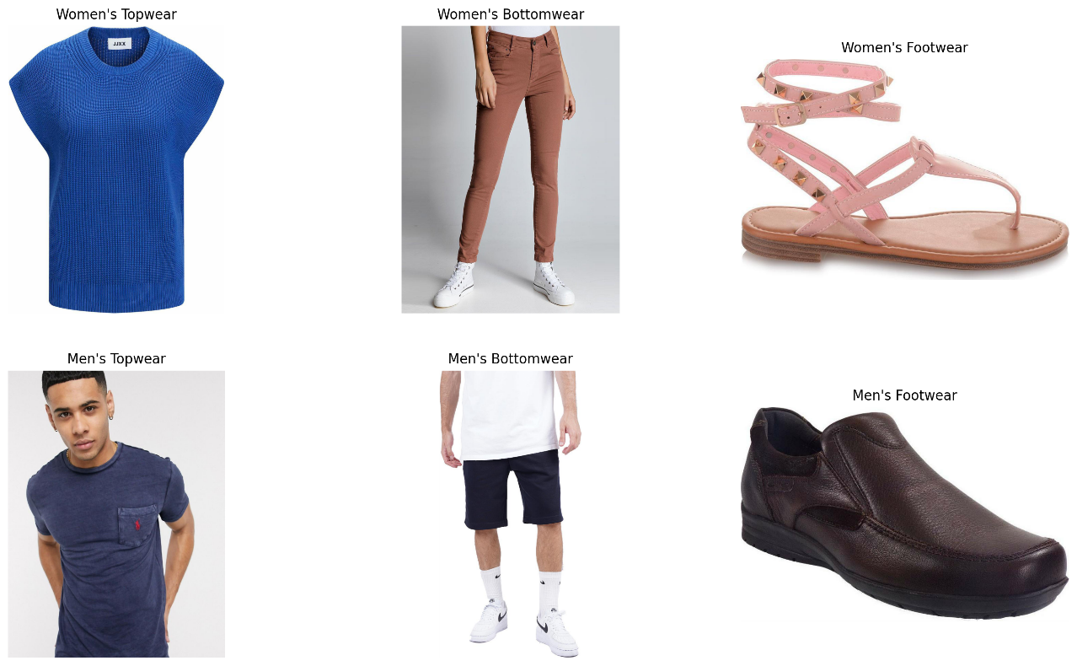

The fashion products are almost equally split among the two genders, there are 5000 Men’s Products whereas as 4600 Women’s products. The plot below is a visual representation of the products split by genders.

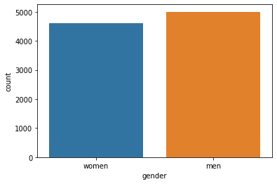

Distribution across the categories of Top wear ~ 4000, Bottom wear ~ 3600 and Footwear ~ 2000.

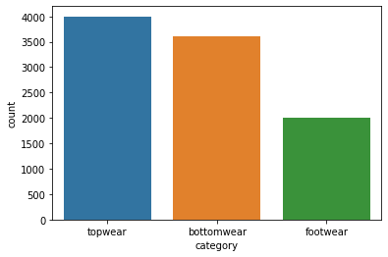

Here we can observe the distribution across product's categories in the dataset. Men's bottom wear have 1000 items each, whereas Women's and Men's top wear have 400 products each.

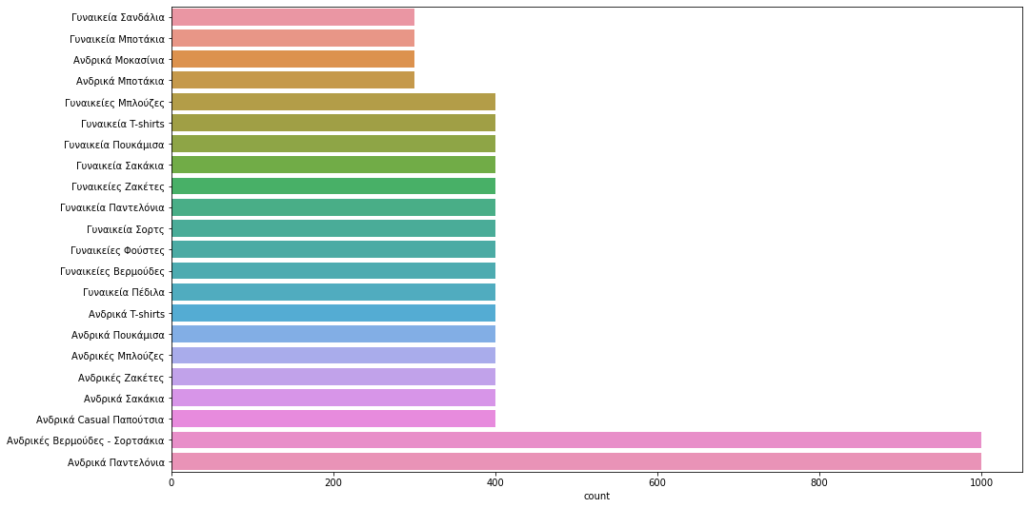

As far as the brands, we can see that Jack & Jones and Ralph Lauren are the most common brands in the dataset, with over 400 products each one.

25 Most Common Brands in the Dataset:

|  |  |
| --- | --- |
| Jack & Jones | 491 |
| Ralph Lauren | 403 |
| BodyTalk | 365 |
| Pepe Jeans | 343 |
| Edward Jeans | 315 |
| Famous Shoes | 240 |
| Sogo | 186 |
| Body Action | 170 |
| Tom Tailor | 162 |
| Adidas | 161 |

## Gender Classification

In order to recommend relevant items to the user we'll have to first detect the gender of the person present in the query image. Doing so will allow us to generate and query embeddings only on certain subsets of the catalogue instead of the whole database. This will also help us in reducing irrelevant recommendations to the user based on their gender.

For this task we'll make use of the [Man/Woman classification dataset from Kaggle](https://www.kaggle.com/playlist/men-women-classification). This is a manually collected and cleaned dataset containing 3354 pictures (jpg) of men (1414 files) and women (1940 files) that includes full body and upper body images of men and women. This is ideal for our use case since we'll mostly have full body images of models wearing various fashion items.

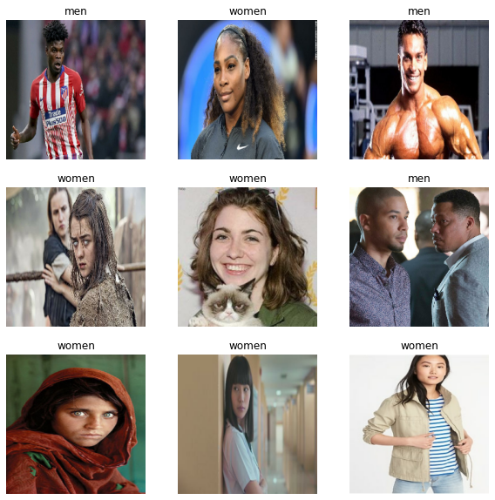

For classification we can use a ResNET50 backbone initialized with 'ImageNet' weights attached to a fully connected network that outputs the probability scores for the two classes. We'll freeze all the layers from the backbone since the task is comparatively easy to achieve and in order to avoid overfitting to this dataset. Below is a code snippet for the model used for classification. We are able to achieve accuracy of 95% on the test set which is decent for our use case.

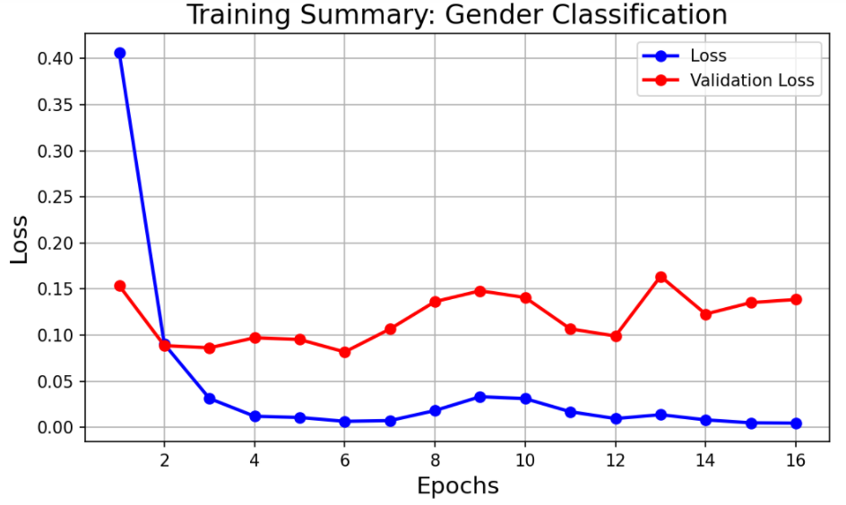

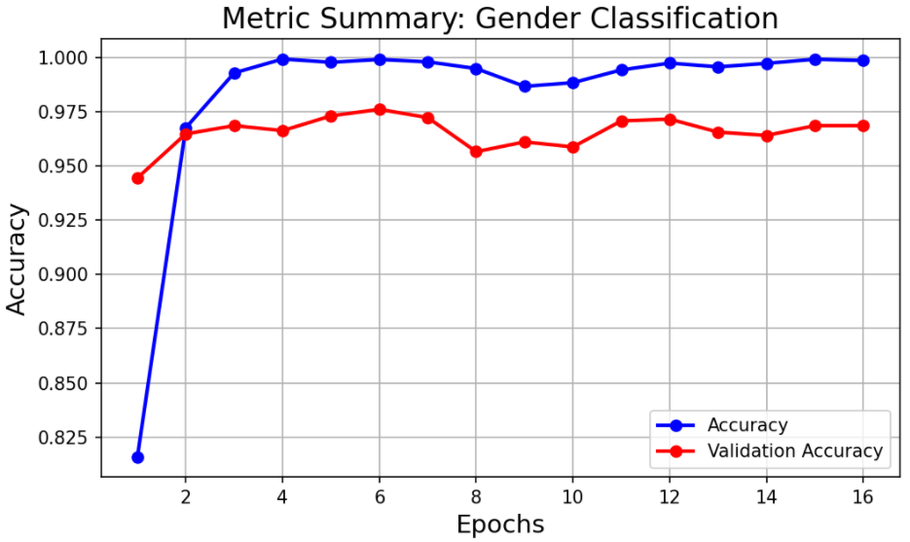

## Object Detection and Localization

In order to recommend similar products, we'll first need to detect all the products in a given image, and for generating the embeddings we'll need to crop out the product from an image.

Object detection is one of the most interesting aspects of Computer Vision. Most object detection systems have some kind of trade-off between inference speed and detection accuracy.

In order to better understand object detection, we'll need to understand a metric called 'mAP' or Mean Average Precision. For object detection whether a detection is considered correct or not depends on the IoU (Intersection over Union) threshold. The IoU score for a predicted bounding box and actual bounding box is defined as

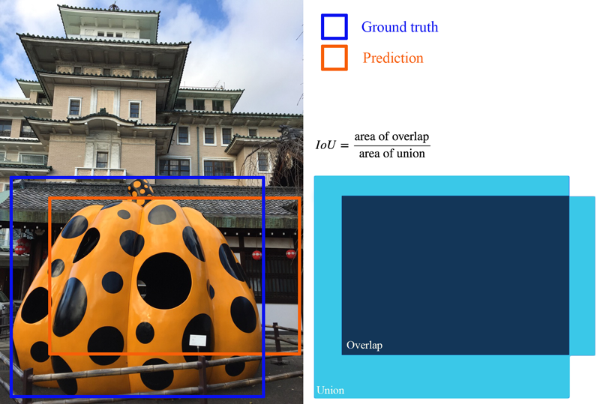

For a pre-defined IoU threshold we can define if a detection was accurate or not if the IoU is greater than the thresold. Based on the detections Precision and Recall is defined as:

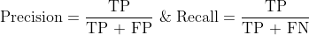

Where TP = True Positive, FP = False Positive & FN = False Negative

The average precision is calculated by using the Area Under the Precision and Recall Curve.

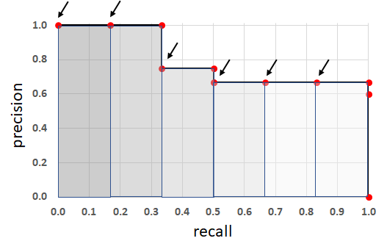

The Mean Average Precision is calculated by taking mean of the Average Precision values over different values of threshold, for example in the COCO Primary Challenge the mAP was calculated by averaging the AP scores over a range of IoU thresholds from 0.5 to 0.95 with a step size of 0.05 and finally taking the mean of the AP scores over all the classes. For more detailed explanation of mAP we followed this blog - "[Breaking Down Mean Average Precision](https://towardsdatascience.com/breaking-down-mean-average-precision-map-ae462f623a52)".

Now that we know how Object Detection Systems are evaluated let's checkout various methods for object detection. We'll compare various object detection model's performance against the MS COCO Dataset that contains 80 classes. We'll look at the Inference speed and mAP scores. Below is a plot showing the highest and lowest Frames Per Second (FPS) values reported in their respective papers.

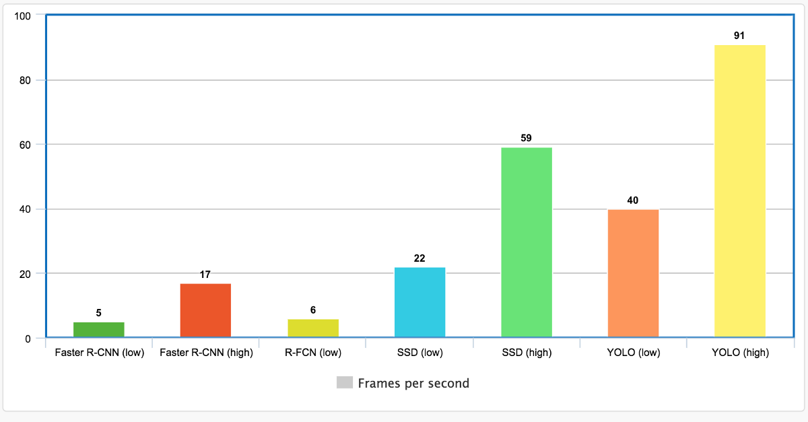

It is clear that YOLO object detection is faster by a huge margin compared to other object detection methods, however an important thing to note is the plot doesn't mention the mAP scores for the models with the highest inference speeds. Now let’s look at mAP scores for various methods against the MS COCO Dataset.

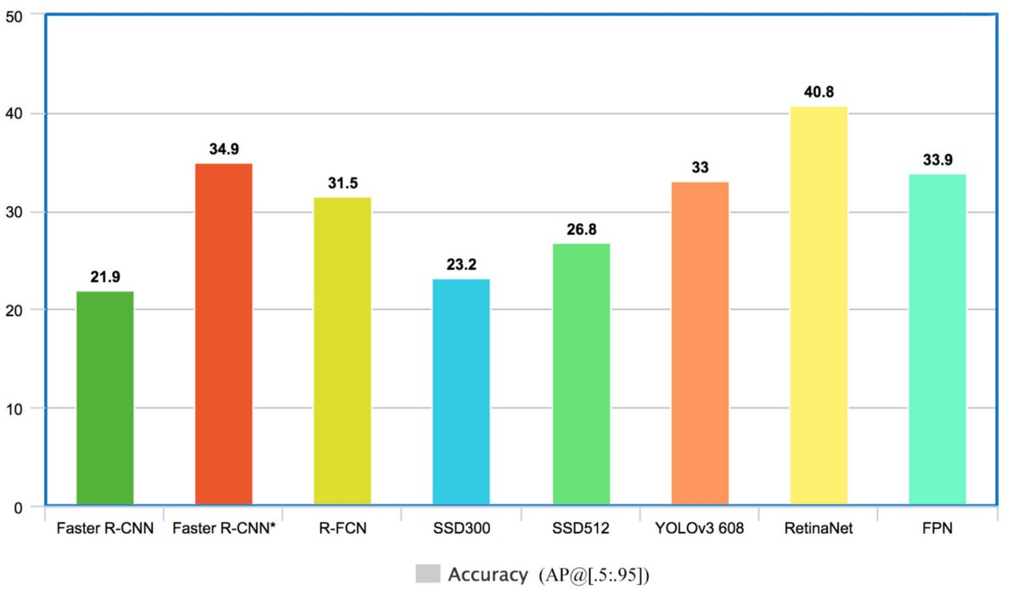

From the plot above we can see that RetinaNET has the highest mAP score of 40.8 followed by Faster-RCNN, FPN and YOLO. The difference between the latter three methods is not huge compared to their difference with RetinaNET which is SOTA in object detection. We can safely assume that YOLO will provide us with the right balance of Accuracy and Speed for our task of Fashion product detection and localisation.

Hence, we'll use YOLO object detection for detecting fashion products in three categories - top wear, bottom wear, and footwear for our simplicity, we can easily improve our recommendation engine by including more and better categories for object detection like classifying the type of shirts, t-shirts, bags, sunglasses, trousers, jeans etc. YOLO refers to “You Only Look Once” is a versatile object detection model. YOLO algorithms divide a given input images into the SxS grid system. Each grid is responsible for object detection. Now the Grid cells predict the boundary boxes for the detected object. For every box, we have five main attributes: x and y for coordinates, w and h for width and height of the object, and a confidence score for that the box containing the object. We have followed this blog for training an object detector using your custom dataset - "[YOLOv5 Training for Custom Dataset](https://blog.roboflow.com/how-to-train-yolov5-on-a-custom-dataset/)"

For training the custom Object Detection model we'll use Transfer Learning. We'll load YOLOv5s (s stands for small variant of YOLOv5) weights trained on the COCO Dataset and use transfer learning to fine-tune the model for our use case.

We have used [this](https://universe.roboflow.com/new-workspace-w4orl/fashion_obj_detection/browse) dataset from Roboflow, of 180 images (135 train and 45 validation) with annotated top wear, bottom wear and footwear. We were able to achieve a mAP score of 0.94 @ 0.5 IoU threshold on a test set of 45 images.

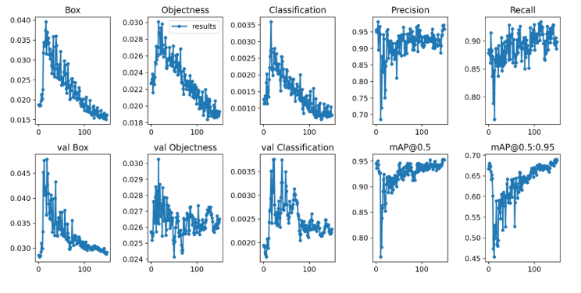

Here are some object detection results on top wear, bottom wear, and footwear detection.

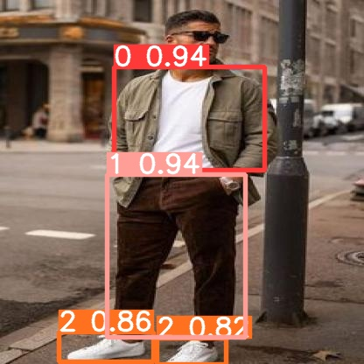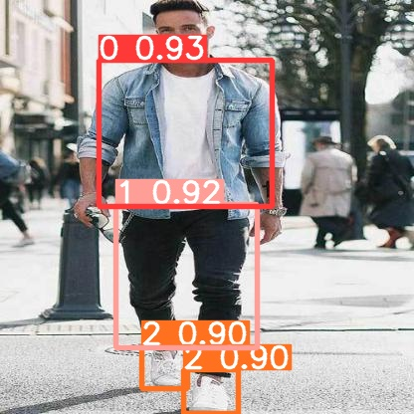

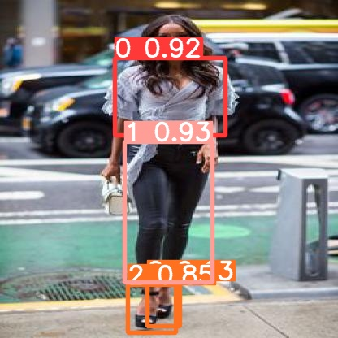

As a final step we have created a function to crop the query image based on the output of the object detection model:

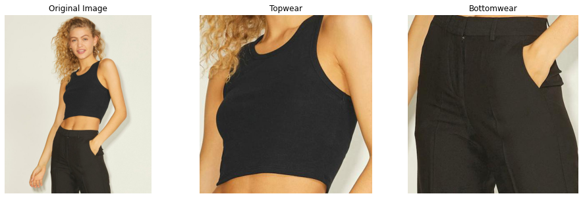

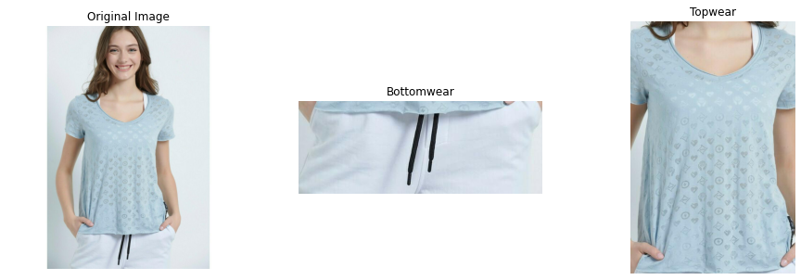

## Embedding Generation

We use embedding generation to represent images/products such that similar ones are grouped together whereas dissimilar ones are moved away so that in order to retrieve products that are similar to the products present in the query image. There are various ways to calculate similarity between images after they are converted into a vector with n-dimensions. Cosine similarity and Euclidean distance are two examples. We can define Cosine similarity and Euclidean distance as –

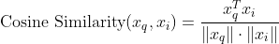









In order to convert images to n-dimensional vector representations of the images, we'll use a special type of Neural Network called Siamese Network. This network which takes in three inputs - anchor, positive and negative, such that anchor, and positive inputs are similar whereas anchor and negative inputs are dissimilar.

The output is three n-dimensional vectors representing anchor, positive and negative inputs generated by a CNN backbone. This network requires a special kind of loss function that minimizes the distance metric between anchor and positive while maximizing the distance metric between anchor and negative hence we'll need an intermediate layer that computes the distance between anchor and positive outputs and anchor and negative outputs. One such loss is the triplet loss which in our case we've defined as –

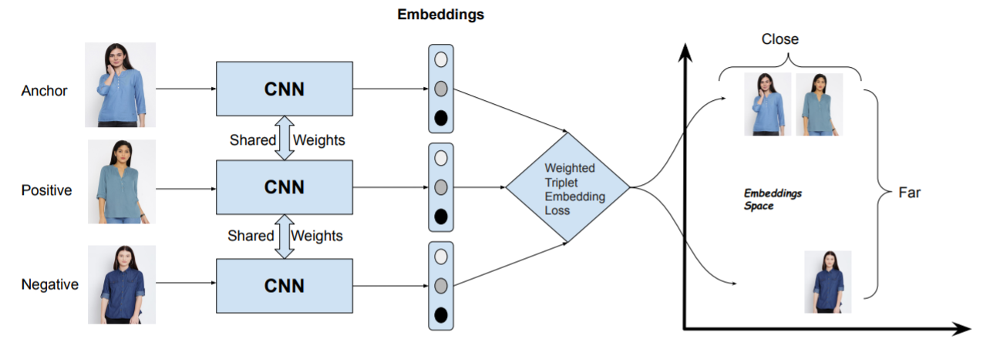





"Shop The Look" is a dataset taken from "[Wang-Cheng Kang, Eric Kim, Jure Leskovec, Charles Rosenberg, Julian McAuley (2019). Complete the Look: Scene-based Complementary Product Recommendation](https://arxiv.org/pdf/1812.01748.pdf)". In Proceedings of IEEE Conference on Computer Vision and Pattern Recognition (CVPR'19). It provides the two datasets for fashion and home respectively with scene and product pairs. Product is an image of a product in professional setting whereas a scene is the image of the same product but in casual or non-professional setting. Each dataset contains the scene-product pairs in the following format, where scene and products are encoded with a signature that can be converted to an URL by using a function provided in the official GitHub repo [STL-Dataset](https://github.com/kang205/STL-Dataset).

We can easily create anchor and positive pairs from this dataset and for generating negative samples we can randomly select scenes from the dataset which is not same as the positive sample

**Top wear**

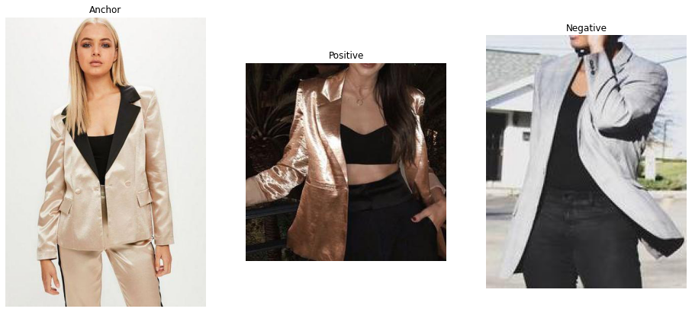

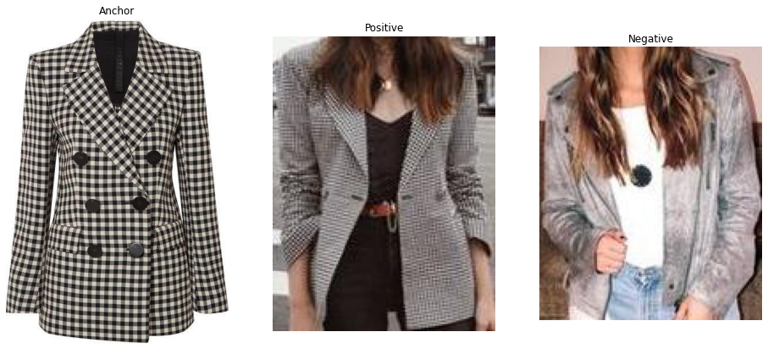

**Bottom wear**

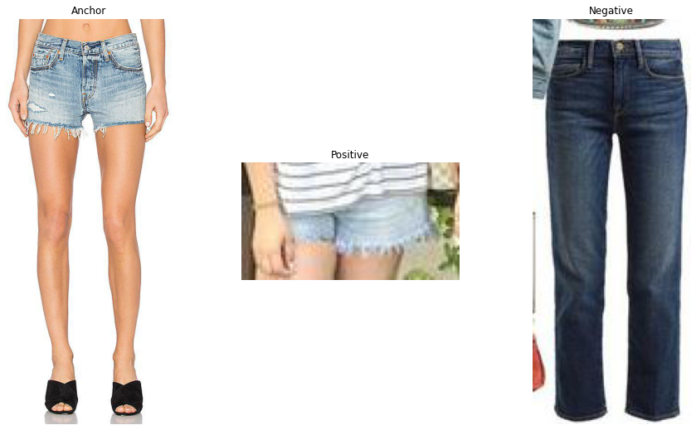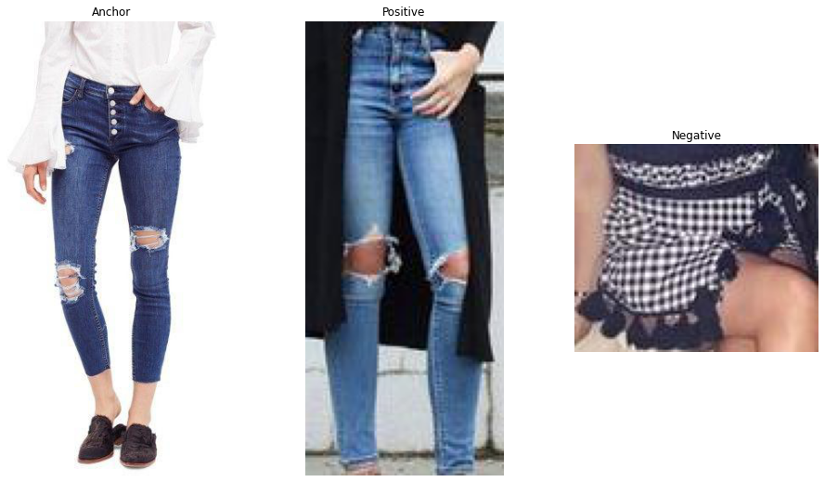

**Footwear**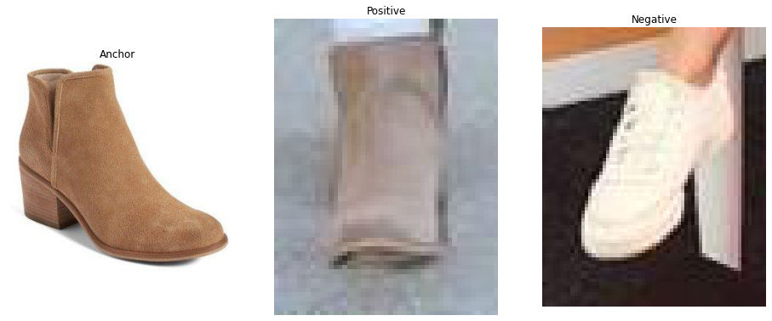

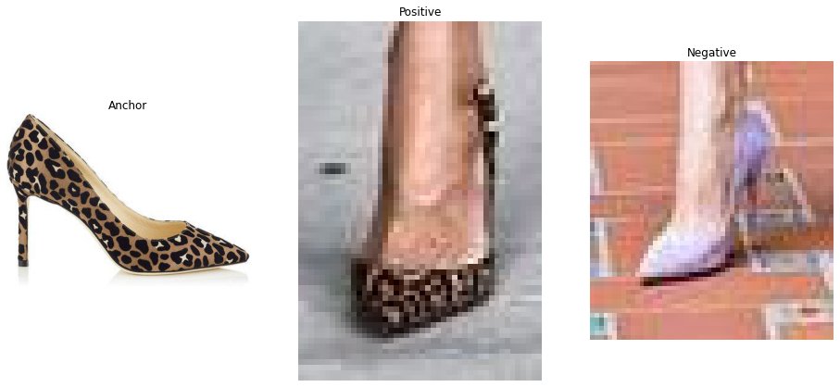

We now move onto to define the Siamese network using TensorFlow and Keras. For a detailed explanation on the definition of the network, we have followed this tutorial from [Keras](https://keras.io/examples/vision/siamese_network/).

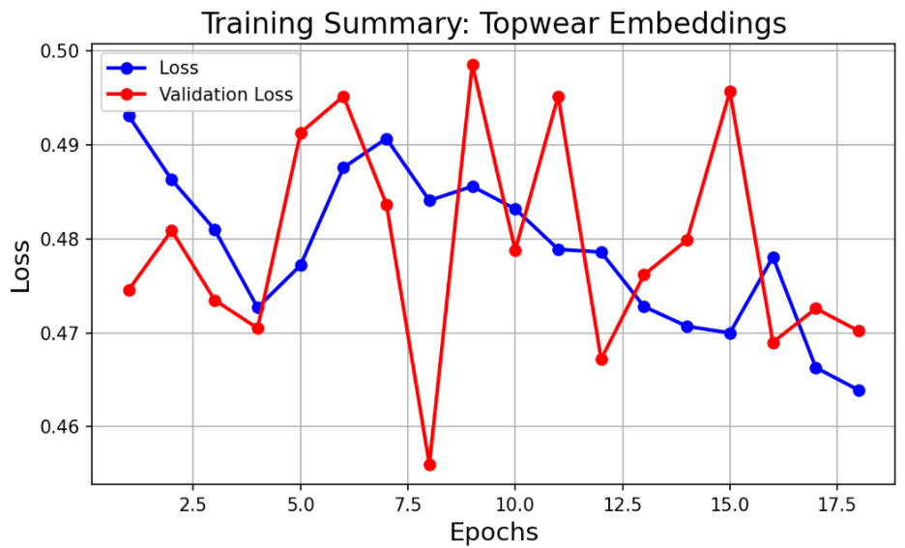

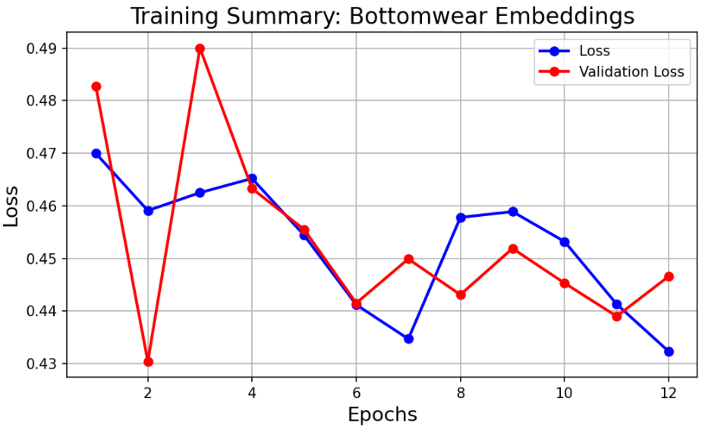

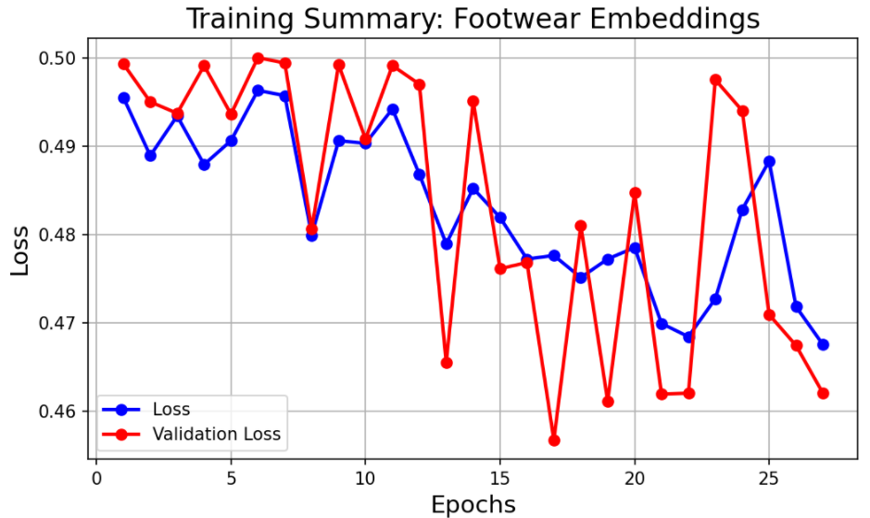

At this point, we can check how the network learned to separate the embeddings depending on whether they belong to similar images. We can use cosine similarity to measure the similarity between embeddings.

Let's pick a sample from the dataset to check the similarity between the embeddings generated for each image.

**Top wear**

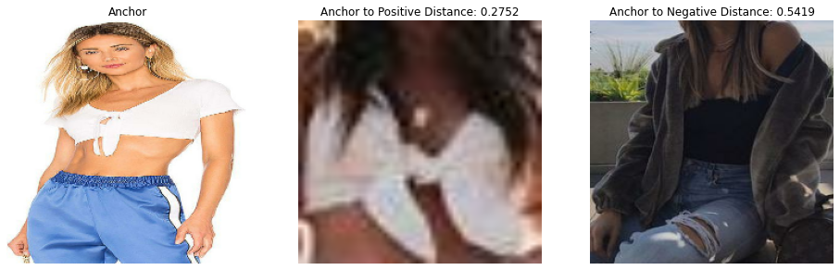

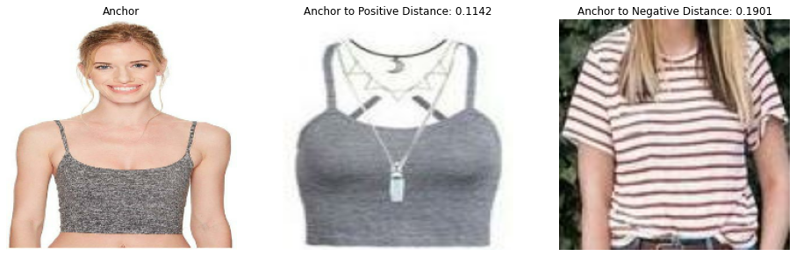

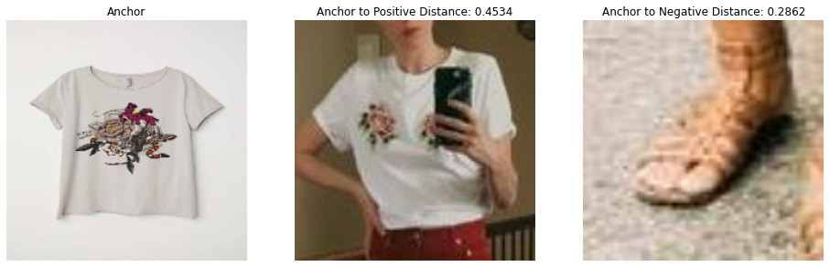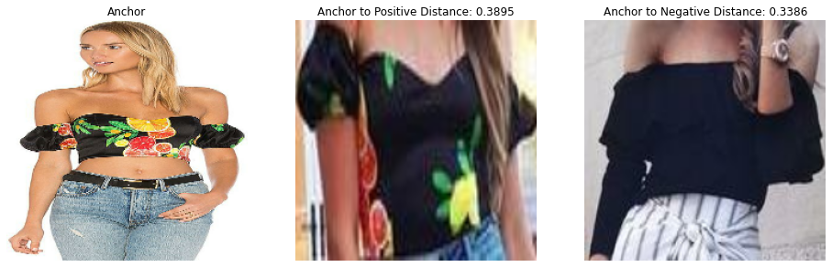

**Bottom wear**

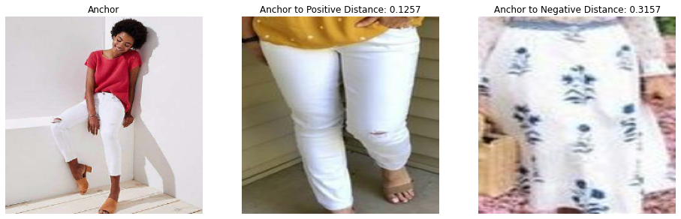

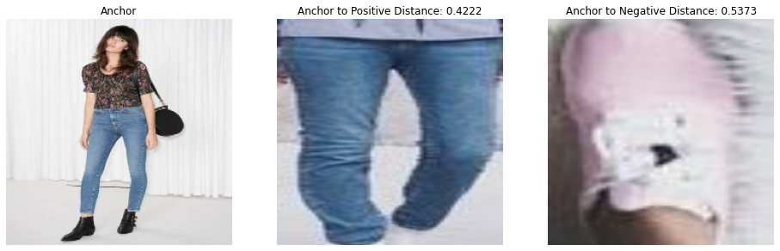

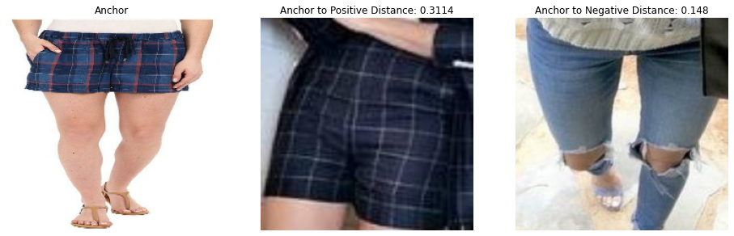

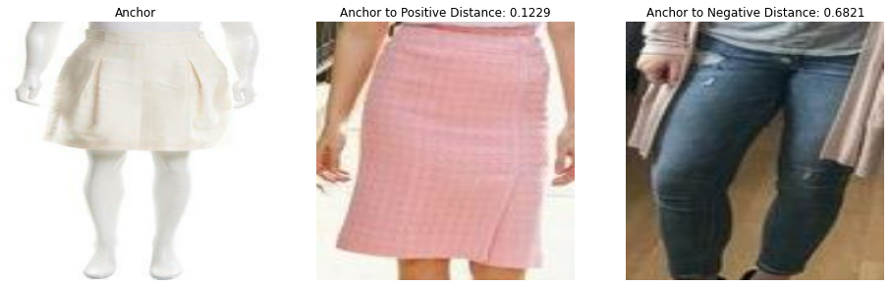

**Footwear**

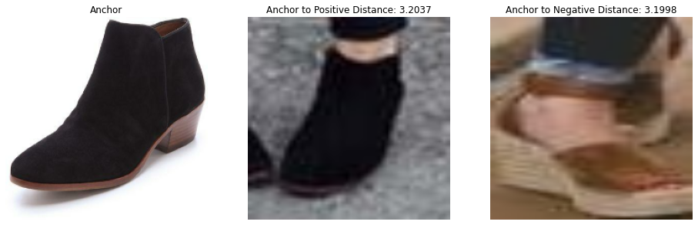

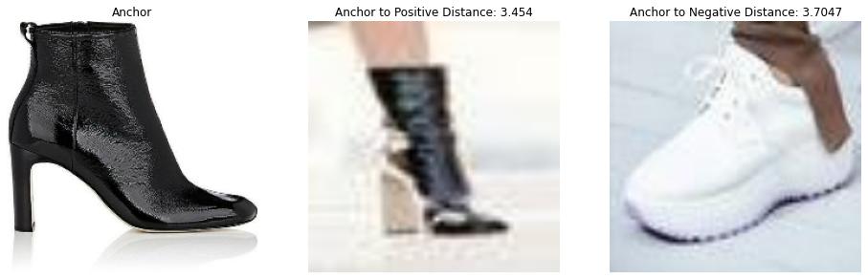

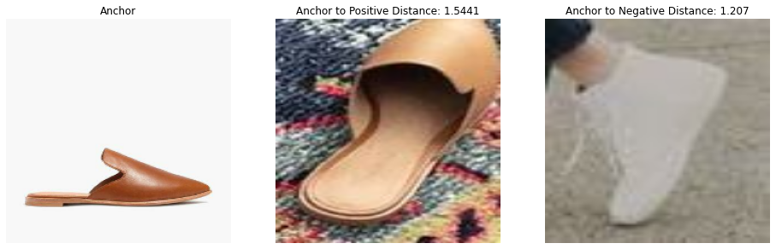

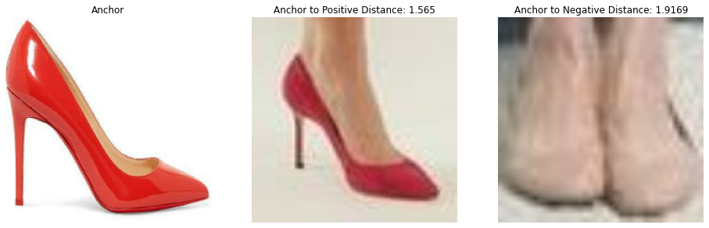

Having trained the embedding generation model, we have to generate and save embeddings for the catalogue of fashion products.

Let’s try now to check the similarity between the embeddings generated for a catalogue image, which is not included in the training dataset.

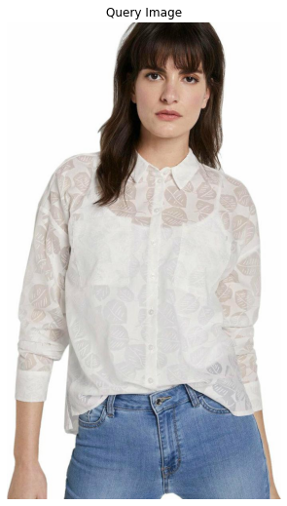

**Images with the maximum similarity**

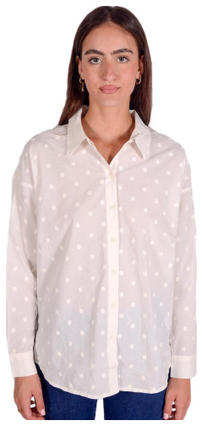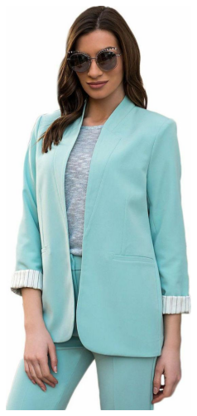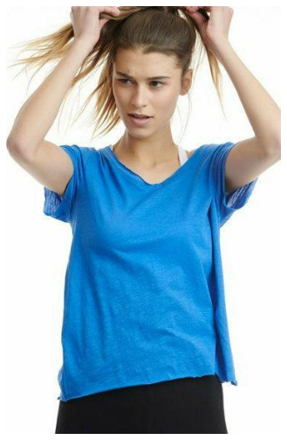

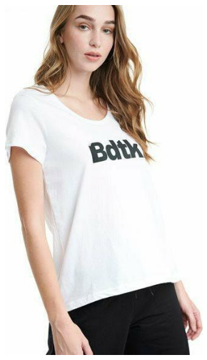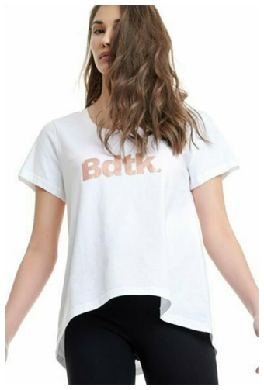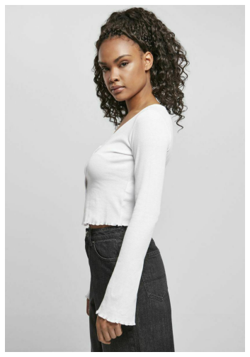

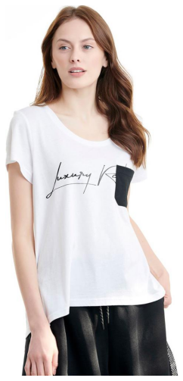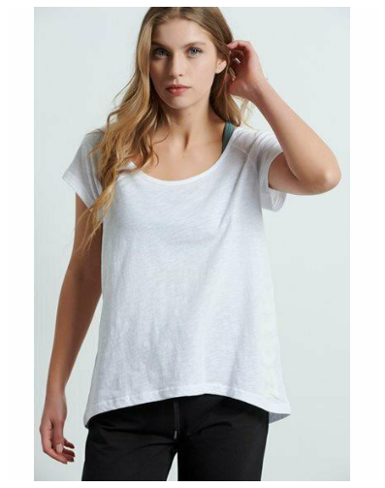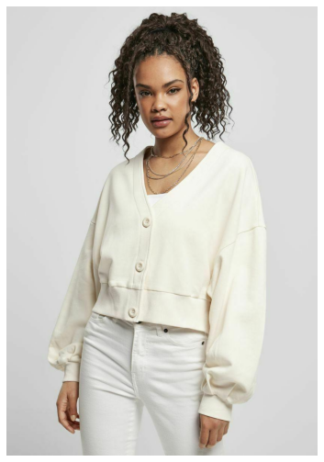

# Experiments – Setup, Configuration

## Final Pipeline

Having generated and stored the embeddings for the catalogue of fashion products, the final step is to combine all the modules into a pipeline that takes in a query image and outputs the relevant recommendations as shown in the diagram below.

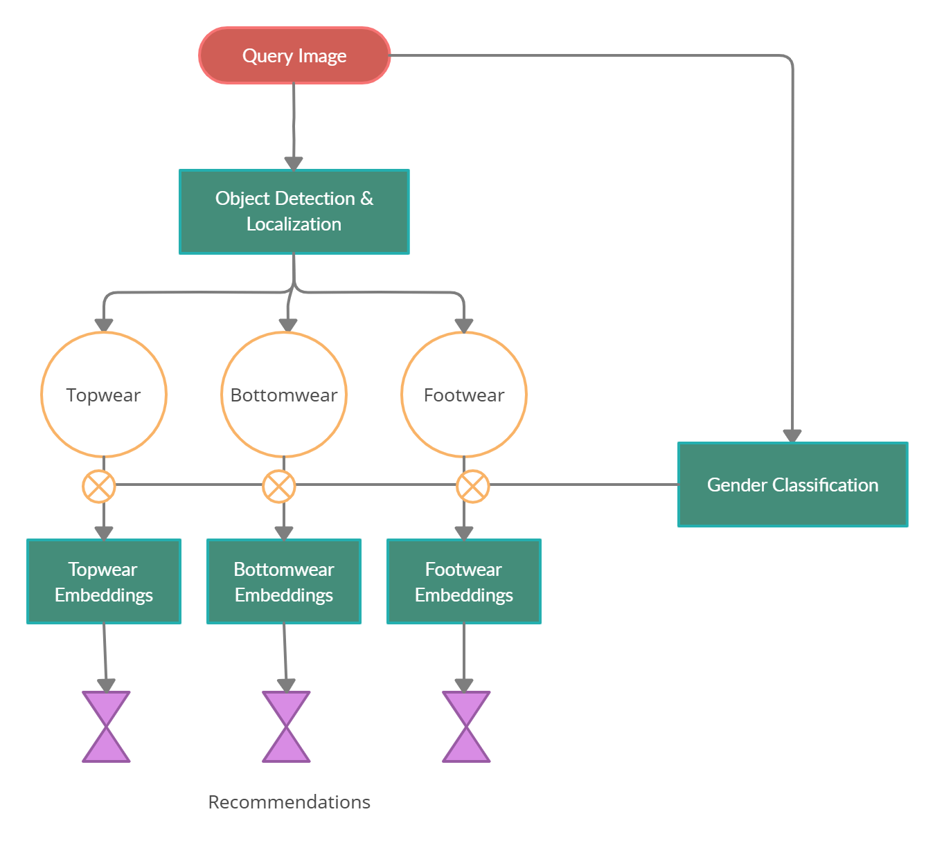

## Results & Quantitative Analysis

Here are some example recommendations from the final pipeline. The first image is the query image followed by the recommendations

----------------------------------------------------------------------------------------------

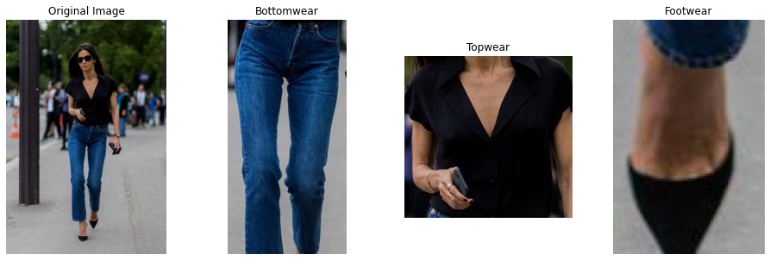

Bottom wear recommendation:

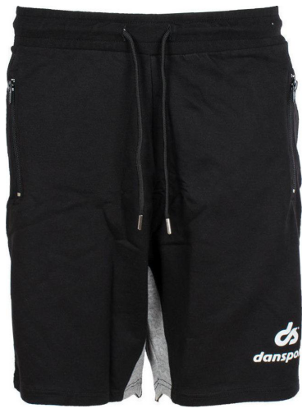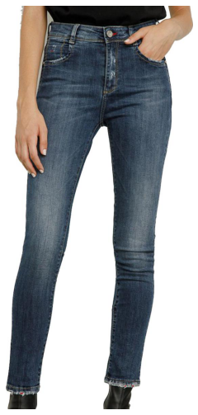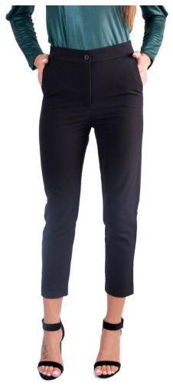

Top wear recommendation:

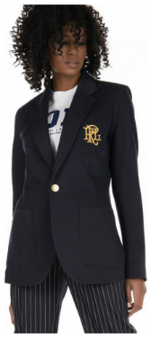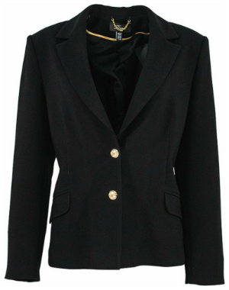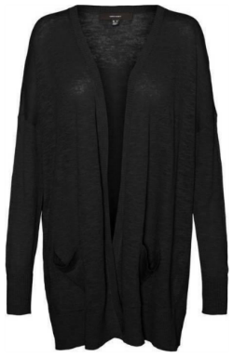

Footwear recommendation:

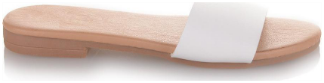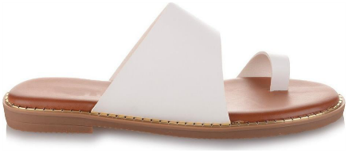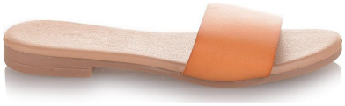

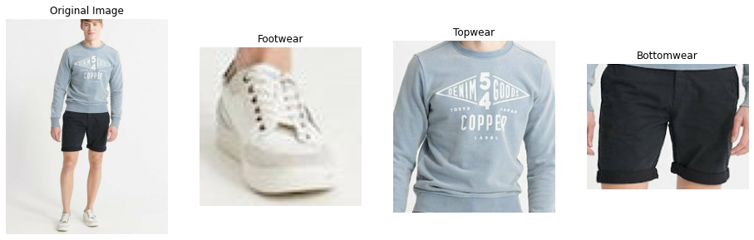

Bottom wear recommendation:

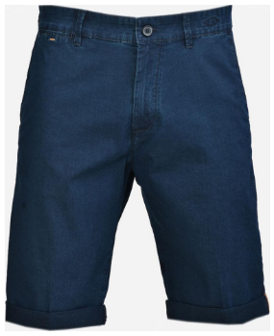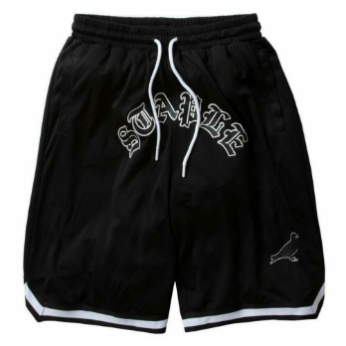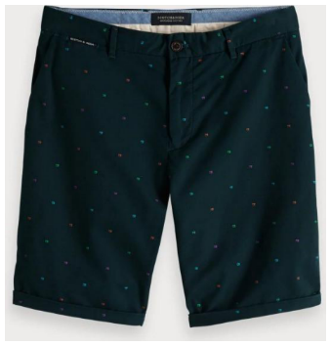

Top wear recommendation:

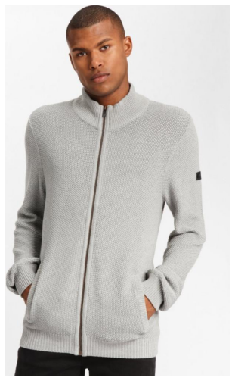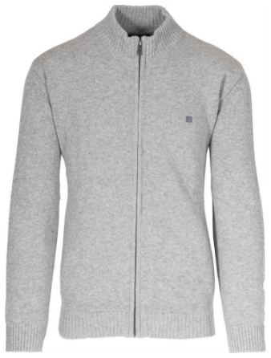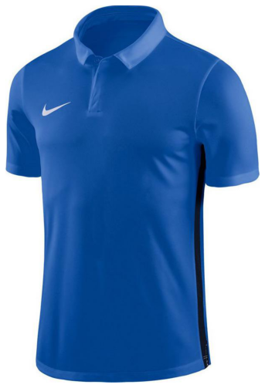

Footwear recommendation:

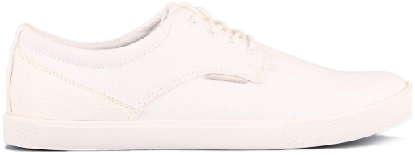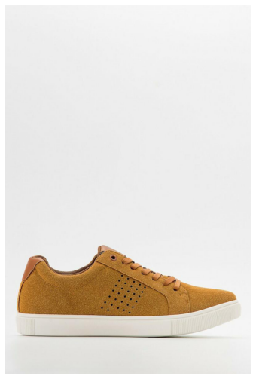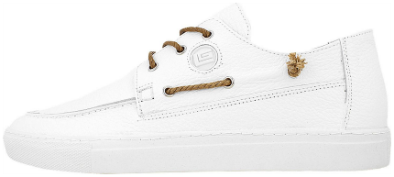

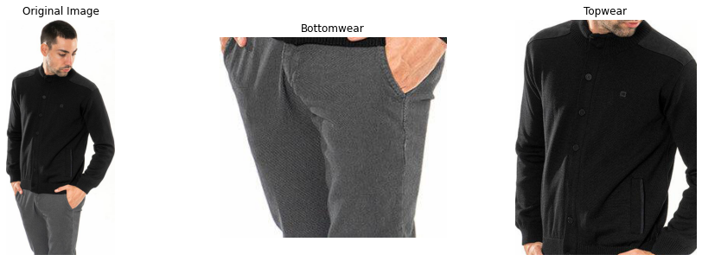

Bottom wear recommendation:

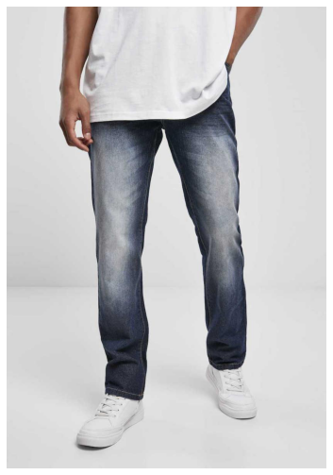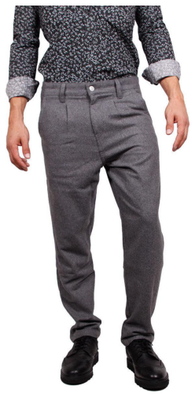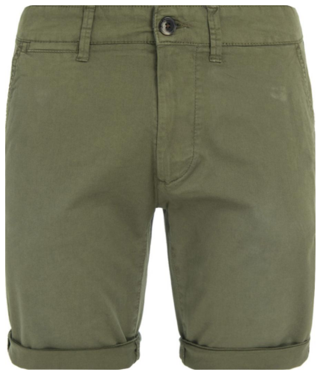

Top wear recommendation:

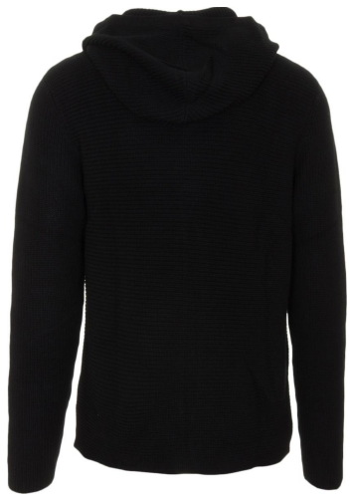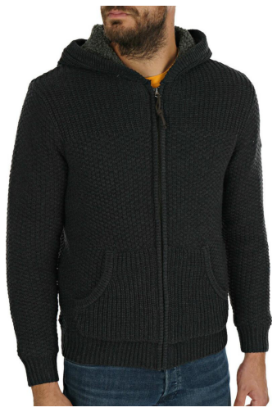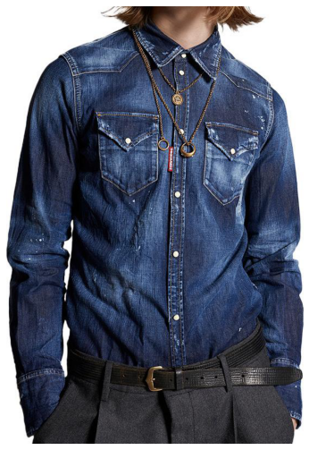

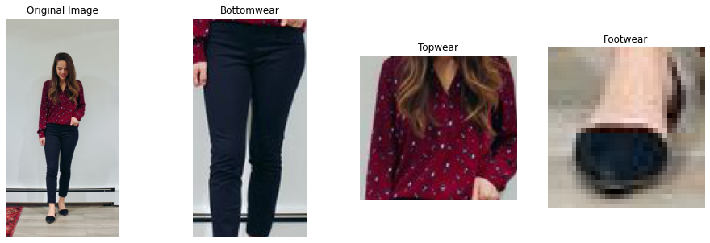

Bottom wear recommendation:

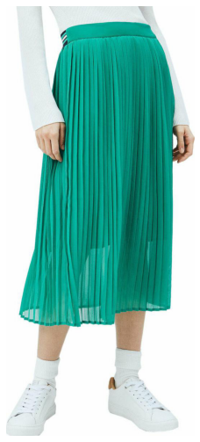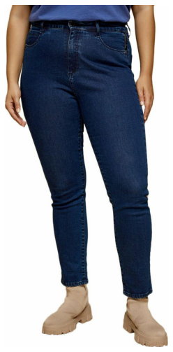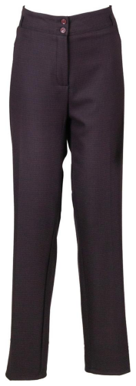

Top wear recommendation:

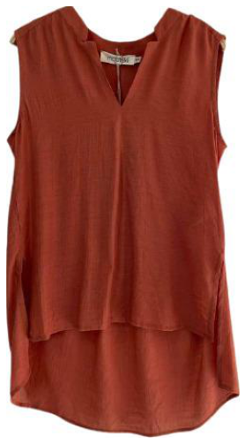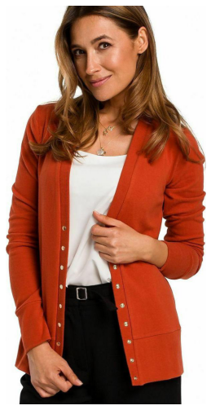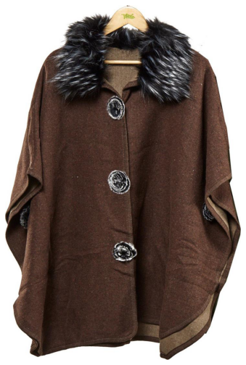

Footwear recommendation:

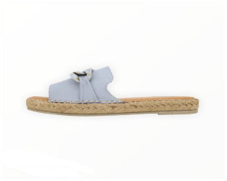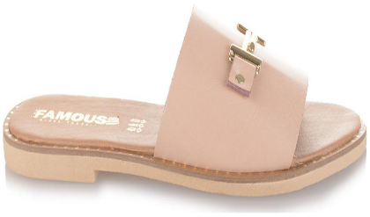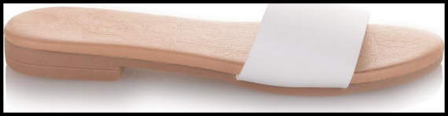

## Further improvements and future work

This system can be considered as a POC (Proof of Concept) for image similarity-based item recommendation engine, further improvements can be made by changing the existing modules with better performing alternatives as the time progresses.

For example, we can change the object detection pipeline to any SOTA algorithms of the time for better detections. Similarly, we can retrain the embedding generation model regularly from time to time as new products are being added to the catalogue. The current object detection only detects top wear, bottom wear, and footwear we can improve it by adding specific classes instead of broad terms, like shirts, t-shirts, suits, pants, trouser, jeans, shoes and also support for other fashion accessories like handbags, sunglasses, watches etc.

The STL-Dataset included lot of pairs where the product and the scene did not match, we can clean the dataset of such pairs and retrain the embedding generation model for higher number of epochs.

Lastly, we need to deploy this system for users to try it out. Before we start predicting from our saved TensorFlow models we can further optimize them by using a technique called post training quantization. Post-training quantization is a conversion technique that can reduce model size while also improving CPU and hardware accelerator latency, with little degradation in model accuracy. One can quantize an already-trained float TensorFlow model when it is converted to TensorFlow Lite format using the TensorFlow Lite Converter. We can virtually reduce the model size by half by converting all the float32 weights to float16.

# Members, Roles & Timeplan

Members/Roles

Your team members

TimePlan

Plan setup: main tasks/phases in the project

A preliminary timeplan on the tasks

# Bibliography

1. [Buy Me That Look: An Approach for Recommending Similar Fashion Products](https://arxiv.org/pdf/2008.11638.pdf)
2. [Complete the Look: Scene-based Complementary Product Recommendation](https://arxiv.org/pdf/1812.01748.pdf)
3. [Men / Women Classification Kaggle Dataset](https://www.kaggle.com/datasets/playlist/men-women-classification)
4. [Breaking Down Mean Average Precision (mAP)](https://towardsdatascience.com/breaking-down-mean-average-precision-map-ae462f623a52)
5. [Object detection: speed and accuracy comparison (Faster R-CNN, R-FCN, SSD, FPN, RetinaNet and YOLOv3)](1.%09https:/jonathan-hui.medium.com/object-detection-speed-and-accuracy-comparison-faster-r-cnn-r-fcn-ssd-and-yolo-5425656ae359)
6. [YOLO - You Only Look Once](https://arxiv.org/pdf/1506.02640v1.pdf)
7. [Ultralytics YOLOv5](https://github.com/ultralytics/yolov5)
8. [How to Train YOLOv5 On a Custom Dataset](https://blog.roboflow.com/how-to-train-yolov5-on-a-custom-dataset/)
9. [Roboflow fashion_object_detection dataset](https://universe.roboflow.com/new-workspace-w4orl/fashion_obj_detection/browse)
10. [YOLOv5 + Roboflow Custom Training Tutorial](https://www.youtube.com/watch?v=x0ThXHbtqCQ&t=568s&ab_channel=Roboflow)
11. [Create YOLO (v5) Dataset for Custom Object Detection using OpenCV, PyTorch and Python Tutorial](https://www.youtube.com/watch?v=NsxDrEJTgRw&ab_channel=VenelinValkov)
12. [Shop the Look Dataset](https://github.com/kang205/STL-Dataset)
13. [Image similarity estimation using a Siamese Network with a triplet loss](https://keras.io/examples/vision/siamese_network/)